Dynamic Programming

Web Experiment #3

Kahekahe Kakai

Experiment Description

2. Time your recursive tsp on **.
Graph, as a function of these five values of n:
(average recursive time)/(2^n),
(average recursive time)/(n*2^n),
(average recursive time)/(n*n*2^n).
Which graph best describes the Big Oh of the experimental data?
Reconcile the graphs with the supposed T(n).

Experiment Summary

Graph 4 is the best approximation of the Big-Oh of the experimental data. The Graph 4 represents the net effect of the other terms versus the Big-Oh on the T(n).

Below is a list of graphs that represent the data that I computed.

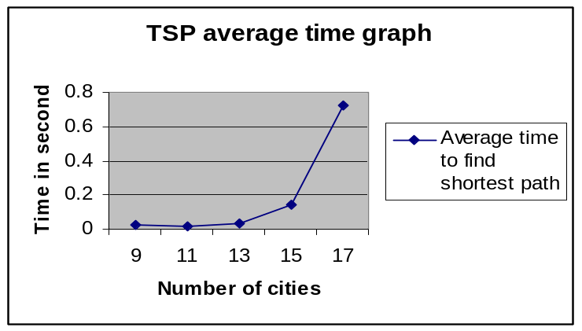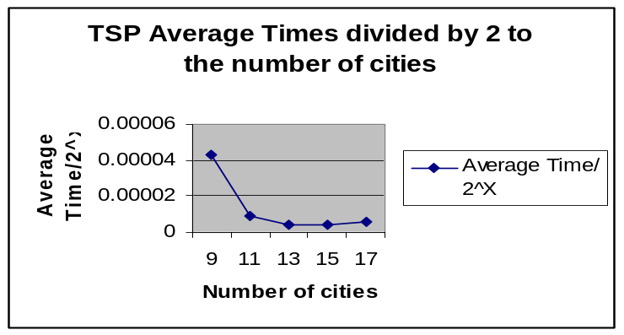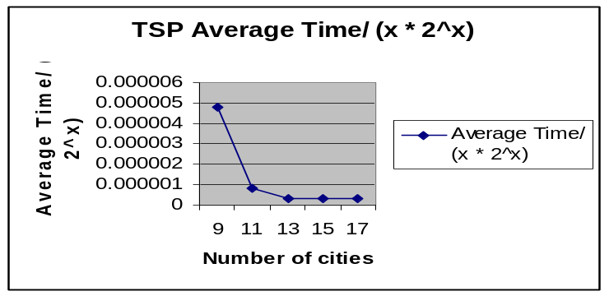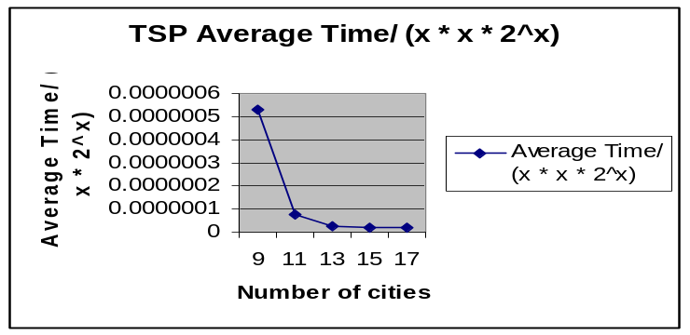Graph 1 Graph 2

Graph 3 Graph 4

Graph 5

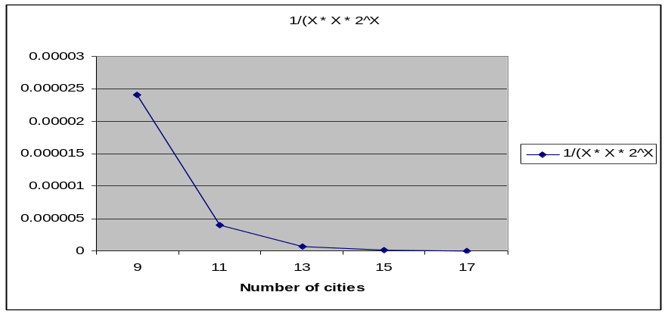We know that dynamic programming using the recursive approach for the Traveling Salesman problem is Big-Oh bound O(n^2 * 2^n). Accordingly I graphed 1/(n * n * 2^n) to give a model of what the normalized graph for the Big-Oh would look like. In Big-Oh you throw away the part that is a factor or more less than the largest factor in the running time equation. Graph 5 shows what the graph would look like if the other factors were simply 1. We would expect the graph of our experimental data that most closely approximated the real Big-Oh to look like Graph 5. Graph 4 is the graph that best approximates that Big-Oh. Graph 2 curves upward at the end while Graph 3 levels off at the tail end both of which suggest that the normalizing of the experimental data is not being done correctly since they differ from the graph of the real Big-Oh.
This can be explained in terms of T(n) also. For low values of n we would expect that the factors thrown away in getting the Big-Oh would have a larger effect on the overall running time of the program. To find out what affect this has in terms of our Big-Oh approximation we get a ratio by dividing the average running time which has the effect of all factors in it by the Big-Oh. In Graph 4 we see real effect that the additional parts have on the running time. Dividing by n^2 * 2^n reduces the effect of the Big-Oh(n^2 * 2^n) to 1 for all values of n so we can graph the resulting effect of (the other stuff)/(Big-Oh). As is expected for low values of n the other stuff has a larger effect hence the high value for the first data point in Graph 4. As n grows the distance between the terms that vary by factors grows and so the net effect of the other terms versus the Big-Oh is negligible in terms of effect on the running time. Thus we see for larger values of n the Big-Oh is a better approximation for the true running time of our program then for smaller values of n.

